**Objective Questions:**

1. What is the distribution of account balances across different regions?

- Solution

select c.Geography,

count(c.CustomerId) as number_of_customers,

round(avg(b.balance),2) as average_balance,

round(sum(b.Balance),2)as total_account_balance

from customerinfo c

inner join bankchurn b

on c.CustomerId = b.CustomerId

group by 1;

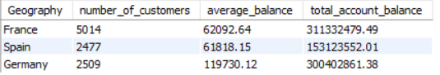

2. Identify the top 5 customers with the highest Estimated Salary in the last quarter of the year. (SQL)

- Solution

select

CustomerId,Surname,

bankdoj,EstimatedSalary

from customerinfo

where extract(month from bankdoj) in (10,11,12)

order by EstimatedSalary desc

limit 5;

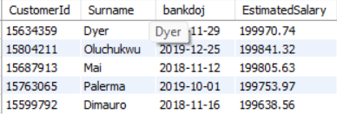

3. Calculate the average number of products used by customers who have a credit card. (SQL)

- Solution

select avg(numofproducts) as avg_of_products

from bankchurn

where HasCreditCard = 1;



4. Determine the churn rate by gender for the most recent year in the dataset.

-Solution

select c.Gender,

count(b.customerid) as churncustomers

from bankchurn b

inner join customerinfo c

on c.CustomerId=b.CustomerId

where year(c.BankDOJ) = 2019 and b.ExitCustomer = 'Exit'

group by 1

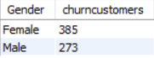

5. Compare the average credit score of customers who have exited and those who remain. (SQL)

-Solution

SELECT Exited,

AVG(CreditScore) AS avg_credit_score

FROM bankchurn

GROUP BY Exited;

-- or we can also solve the same using CTE (Comman table expression)

WITH cte1 AS

(SELECT 'Exit' AS status,

AVG(CreditScore) AS avg_credit_score

FROM bankchurn

WHERE ExitCustomer = 'Exit'),

cte2 AS

(SELECT 'Retain' AS status,

AVG(CreditScore) AS avg_credit_score

FROM bankchurn

WHERE ExitCustomer = 'Retain')

SELECT

cte1.avg_credit_score AS avg_credit_score_of_exit_customers,

cte2.avg_credit_score AS avg_credit_score_of_retain_customers,

(cte2.avg_credit_score-cte1.avg_credit_score) AS compared_avg

FROM cte1 inner JOIN cte2 on 1=1;

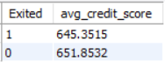

For reference question no. 5 in SQL.

6. Which gender has a higher average estimated salary, and how does it relate to the number of active accounts? (SQL)

-Solution

WITH CTE1 AS

(SELECT c.Gender,AVG(c.EstimatedSalary) AS AvgSalary,

SUM(CASE WHEN b.ActiveCustomer = 'Active Member' THEN 1 ELSE 0 END) AS ActiveAccounts

FROM customerinfo c

inner join bankchurn b ON c.CustomerId = b.CustomerId

GROUP BY c.Gender)

SELECT Gender,ROUND(AvgSalary, 2) AS AvgSalary,ActiveAccounts

FROM CTE1 order by AvgSalary desc limit 1;



7. Segment the customers based on their credit score and identify the segment with the highest exit rate. (SQL)

-Solution

WITH CreditScoreSegments AS (SELECT

CASE WHEN CreditScore BETWEEN 800 AND 850 THEN 'Excellent'

WHEN CreditScore BETWEEN 740 AND 799 THEN 'Very Good'

WHEN CreditScore BETWEEN 670 AND 739 THEN 'Good'

WHEN CreditScore BETWEEN 580 AND 669 THEN 'Fair'

WHEN CreditScore BETWEEN 300 AND 579 THEN 'Poor'

ELSE 'Unknown'END AS CreditScoreSegment,

COUNT(*) AS TotalCustomers,

SUM(Exited) AS ChurnedCustomers,

100 * SUM(Exited) / COUNT(*) AS ExitRate FROM Bankchurn

GROUP BY CreditScoreSegment)

SELECT CreditScoreSegment,TotalCustomers,ChurnedCustomers,ExitRate

FROM CreditScoreSegments

ORDER BY ExitRate DESC

LIMIT 1;



8. Find out which geographic region has the highest number of active customers with a tenure greater than 5 years. (SQL)

-Solution

select c.Geography,

count(b.customerid) as number_of_customers

from customerinfo c

inner join bankchurn b

on c.CustomerId=b.CustomerId

where b.IsActiveMember =1 and Tenure > 5

group by 1

order by 2 desc

limit 1;



9. What is the impact of having a credit card on customer churn, based on the available data?

-Solution

Select

CreditCard,

SUM(Case When ActiveCustomer = 'Active Member' Then 1 Else 0 END) AS ActiveCustomers,

SUM(Case When ActiveCustomer = 'Inactive Member' Then 1 Else 0 END) AS InactiveCustomers,

SUM(Case When ExitCustomer = 'Exit' Then 1 ELSE 0 END) AS ExitCustomers,

SUM(Case WHen ExitCustomer = 'Retain' Then 1 Else 0 END) AS RetainedCustomers,

COUNT(customerID) AS OverallTotalCustomers

From bankchurn

Group by CreditCard;



10. For customers who have exited, what is the most common number of products they have used?

-Solution

Select

NumofProducts,

COUNT(CustomerID) AS NumOfCustomers

From Bankchurn

Where ExitCustomer = 'Exit'

Group by NumofProducts

Order by NumofCustomers DESC

LIMIT 1;

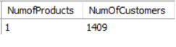

11. Examine the trend of customers joining over time and identify any seasonal patterns (yearly or monthly). Prepare the data through SQL and then visualize it.

-Solution

-- Prepare the data through SQL and then visualize it.

-- Yearly Trend

Select

YEAR(BankDOJ) AS JoiningYear,

COUNT(CustomerID) AS NumofCustomers

From customerINFO

Group by JoiningYear

Order by joiningyear;

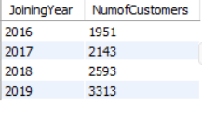

**12. Analyze the relationship between the number of products and the account balance for customers who have exited.**

-Solution

Select

NumofProducts, round(AVG(Balance),2) AS AvgBalance,

MIN(Balance) AS MinBalance,

MAX(Balance) AS MaxBalance,

round(SUM(Balance),2) AS TotalBalance

From BankChurn

WHere ExitCustomer = 'Exit'

Group by NumofProducts;

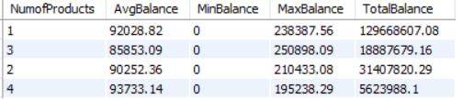

**13. Identify any potential outliers in terms of balance among customers who have remained with the bank.**

-Solution

Select

customerID,

Exitcustomer,

Balance

From Bankchurn

Where ExitCustomer LIKE 'Retain'

Order by Balance DESC;

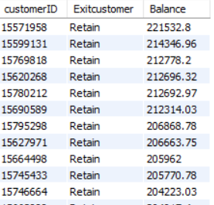

For reference please check qus. 13 in SQL

**14. How many different tables are given in the dataset, out of these tables which table only consists of categorical variables?**

-Solution

* The dataset contains seven different tables, five of which consist solely of categorical variables.
* The "BankChurn" table includes continuous variables such as balance and the number of products.
* The "CustomerInfo" table includes the continuous variable estimated salary.

15. Using SQL, write a query to find out the gender-wise average income of males and females in each geography id. Also, rank the gender according to the average value. (SQL)

-Solution

WITH GenderAvgIncome AS

(SELECT Geography,Gender,

AVG(EstimatedSalary) AS AvgIncome

FROM customerinfo GROUP BY 1,2),

RankedGenderAvgIncome AS

(SELECT Geography, Gender,AvgIncome,

RANK() OVER (PARTITION BY Geography ORDER BY AvgIncome DESC) AS Ranked

FROM GenderAvgIncome)

SELECT Geography,Gender,round(AvgIncome ,2)as AvgIncome,Ranked

FROM RankedGenderAvgIncome

ORDER BY Geography, Ranked;

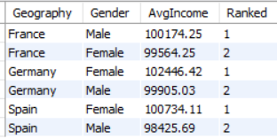

16. Using SQL, write a query to find out the average tenure of the people who have exited in each age bracket (18-30, 30-50, 50+).

-Solution

Select Case

When AGE Between 18 And 30 Then '18-30'

When AGE Between 31 and 50 Then '31-50'

ELSE '50+' END AS AgeBracket,

ROUND(AVG(tenure),2) AS AverageTenure

From customerinfo c

JOIN Bankchurn b ON

c.customerID = b.customerID

Where ExitCustomer = 'Exit'

Group by AgeBracket;

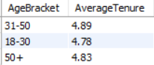

**17. Is there any direct correlation between salary and the balance of the customers? And is it different for people who have exited or not?**

-Solution

These SQL queries calculate the correlation coefficient between salary and balance for all customers, and separately for churned and non-churned customers:

* For all customers, there is a weak positive correlation (0.0128), indicating a slight positive relationship between salary and balance.
* For churned customers, the correlation coefficient is -0.0125, and for non-churned customers, it is 0.0172, both close to zero.

For reference, please check my SQL query Q .No. 17

**18. Is there any correlation between the salary and the Credit score of customers?**

-Solution

* This SQL query calculates the correlation coefficient between customers' salary and credit score.
* The resulting coefficient of -0.0014 indicates a very weak correlation.
* Overall, there is minimal evidence of a significant correlation between salary and credit score

SELECT ROUND((COUNT(*) * SUM(EstimatedSalary * CreditScore) - SUM(EstimatedSalary) * SUM(CreditScore)) /

SQRT((COUNT(*) * SUM(EstimatedSalary * EstimatedSalary) - POW(SUM(EstimatedSalary), 2)) *

(COUNT(*) * SUM(CreditScore * CreditScore) - POW(SUM(CreditScore), 2))),4) AS Correlation_Salary_CreditScore

FROM customerinfo c join bankchurn ch on c.customerid=ch.CustomerId;



19. Rank each bucket of credit score as per the number of customers who have churned the bank.

SELECT CASE

WHEN CreditScore BETWEEN 800 AND 850 THEN 'Excellent'

WHEN CreditScore BETWEEN 740 AND 799 THEN 'Very Good'

WHEN CreditScore BETWEEN 670 AND 739 THEN 'Good'

WHEN CreditScore BETWEEN 580 AND 669 THEN 'Fair'

WHEN CreditScore BETWEEN 300 AND 579 THEN 'Poor'

ELSE 'Unknown'END AS CreditScoreCaregory, COUNT(*) AS NumChurnedCustomers,

DENSE_RANK() OVER (ORDER BY COUNT(*) DESC) AS CreditRank

FROM Bankchurn

WHERE ExitCustomer = 'Exit'

GROUP BY CreditScoreCaregory

ORDER BY CreditRank;

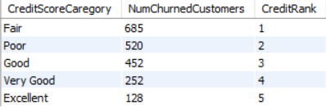

20. According to the age buckets find the number of customers who have a credit card. Also retrieve those buckets that have lesser than average number of credit cards per bucket.

-Solution

SELECT CASE

WHEN Age BETWEEN 18 AND 30 THEN '18-30'

WHEN Age BETWEEN 30 AND 50 THEN '30-50'

WHEN Age >= 50 THEN '50+' ELSE 'Unknown' END AS AgeBucket,

COUNT(*) AS NumofCustomers FROM customerinfo c

JOIN bankchurn bc on c.CustomerId=bc.CustomerId

WHERE CreditCard=1

group by AgeBucket;

-----------------------------------

WITH CreditCardCounts AS

(SELECT CASE

WHEN Age BETWEEN 18 AND 30 THEN '18-30'

WHEN Age BETWEEN 31 AND 50 THEN '31-50'

WHEN Age >= 51 THEN '50+'

ELSE 'Unknown'END AS AgeBucket,

SUM(CreditCard) AS CreditCardCount,

COUNT(*) AS TotalCustomers

FROM customerinfo c join bankchurn bc on c.CustomerId=bc.CustomerId

GROUP BY AgeBucket),

AverageCreditCards AS

(SELECT AVG(CreditCardCount) AS AvgCreditCards

FROM CreditCardCounts)

SELECT AgeBucket,CreditCardCount,TotalCustomers

FROM CreditCardCounts

WHERE CreditCardCount < (SELECT AvgCreditCards FROM AverageCreditCards);

For Reference please check QUS 20 in SQL

21.  Rank the Locations as per the number of people who have churned the bank and average balance of the customers.

-Solution

WITH LocationChurnStats AS

(SELECT Geography,

COUNT(*) AS NumChurnedCustomers,

ROUND(AVG(Balance),2) AS AvgBalance

FROM customerinfo c

JOIN Bankchurn bc ON c.CustomerId = bc.CustomerId

WHERE Exited = 1 GROUP BY Geography)

SELECT Geography, NumChurnedCustomers, AvgBalance,

RANK() OVER (ORDER BY NumChurnedCustomers DESC, AvgBalance DESC) AS LocationRank

FROM LocationChurnStats

ORDER BY LocationRank;

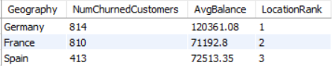

**22. As we can see that the “CustomerInfo” table has the CustomerID and Surname, now if we have to join it with a table where the primary key is also a combination of CustomerID and Surname, come up with a column where the format is “CustomerID_Surname”.**

**-Solution**

To justify the creation of a new column named "CustomerID_Surname" as part of the result set from a join between the "CustomerInfo" table and another table, consider the following steps:

1. **Ensure Data Types:**
   * Verify that the CustomerID in the "CustomerInfo" table is of a character data type or can be converted to one. This ensures compatibility during concatenation.
2. **Perform Join on Individual Columns:**
   * Execute the join between the tables on the relevant columns before concatenating CustomerID and Surname to form the new column "CustomerID_Surname." This allows you to accurately combine data from both tables.

**23. Without using “Join”, can we get the “ExitCategory” from ExitCustomers table to Bank_Churn table? If yes do this using SQL.**

Answer: Yes, we can retrieve the "ExitCategory" from the ExitCustomers table using a subquery in SQL. However, I have already completed this step in Excel during the data cleaning process. Below is the query for reference:

SELECT *,

(SELECT e.ExitCategory

FROM ExitCustomers e

WHERE e.ExitID = b.Exited) AS ExitCategory

FROM BankChurn b;

**24. Were there any missing values in the data, using which tool did you replace them and what are the ways to handle them?**

**-Solution**

There are no missing values present in the provided dataset. However, there were some special characters in the surname column and incorrect statuses in the active status column for customers. These issues have been addressed and corrected during the data cleaning process.

**25. Write the query to get the customer IDs, their last name, and whether they are active or not for the customers whose surname ends with “on”.**

**-Solution**

select c.CustomerId,c.Surname,b.ActiveCustomer

from customerinfo c

inner join bankchurn b

on c.CustomerId=b.CustomerId

where c.Surname like "%on";

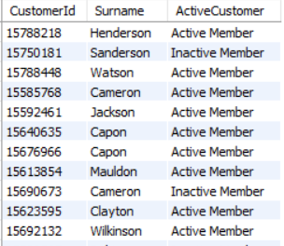

**26. Can you observe any data disrupency in the Customer’s data? As a hint it’s present in the IsActiveMember and Exited columns. One more point to consider is that the data in the Exited Column is absolutely correct and accurate.**

**-Solution**

* A data discrepancy was observed in the customer data, specifically in the "IsActiveMember" and "Exited" columns.
* Customers who had exited were incorrectly marked as active members.
* 735 rows were identified with this inconsistency.
* To rectify this, all instances of exited customers were updated to reflect inactive membership.

**Subjective Question:**

**1.Customer Behavior Analysis: What patterns can be observed in the spending habits of long-term customers compared to new customers, and what might these patterns suggest about customer loyalty?**

**-Solution**

The analysis of customer spending patterns uncovers significant insights from two charts that highlight the average balance and salary of both new and long-term customers:

* ﻿February in Customer category Old Customer made up 4.44% of Average balance.
* ﻿Average balance was higher for Old Customer (76,867.94) than New Customer (76,693.56).
* ﻿Average balance for Old Customer and New Customer diverged the most when the Month was February, when Old Customer were 12,791.12 higher than New Customer.

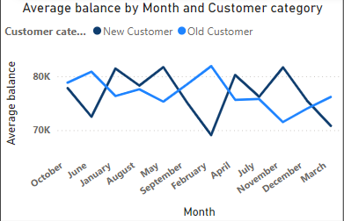

**Average Salary**

* Long-term customers (orange line) have higher average salaries than new customers (blue line).
* New customers show a slight upward salary trend over time.
* Correlation between customer status and salary is observed.

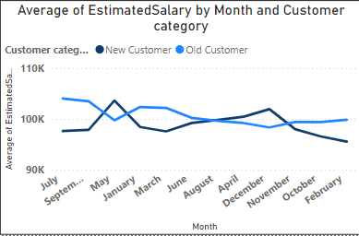

These findings underscore the correlation between customer loyalty and increased spendings, salary offering crucial insights for refining the bank's marketing and retention strategies.

**2.Product Affinity Study: Which bank products or services are most commonly used together, and how might this influence cross-selling strategies?**

**-Solution**

Customers frequently use certain bank products in conjunction with one another. By analysing these combinations, banks can create targeted cross-selling strategies to enhance customer satisfaction and revenue.

**Commonly Used Products:**

* Checking Accounts: Crucial for everyday transactions.
* Debit Cards: Linked to checking accounts, offering easy access to funds.
* Savings Accounts: Help grow savings and typically earn interest.
* Credit Cards: Provide credit lines for purchases, with interest repayment.
* Loans: Include tailored financial solutions like mortgages or auto loans.

**Cross-Selling Strategies:**

* **Recommend Complementary Products:** For example, suggest debit cards and online banking to checking account holders for easier management. Savings account users might benefit from automatic transfers or higher-interest options such as CDs.
* **Personalize Based on Usage:** Offer travel rewards cards to credit card users who travel frequently. Provide bundled insurance options to those seeking loans.
* **Leverage Digital Platforms:** Promote paperless statements, bill autopay,investment options, and financial tools through online or mobile banking.

By understanding product usage patterns and tailoring recommendations accordingly, banks can increase revenue while effectively meeting customers' financial needs.

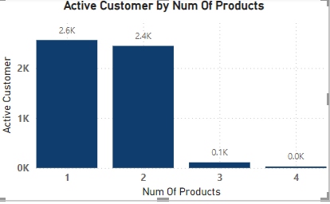

**3. Geographic Market Trends: How do economic indicators in different geographic regions correlate with the number of active accounts and customer churn rates?**

-Solution

This section examines the variation of economic indicators across different geographic regions and their potential correlation with customer churn rates. We will focus on three main economic indicators: average balance, average salary, and credit score.

**Average Balance by Geographic Location:**

* The chart illustrates the average balance in various locations, with Germany having the highest balance.
* While not directly connected to churn, regions with lower balances might see higher churn rates if customers are more cost-sensitive.

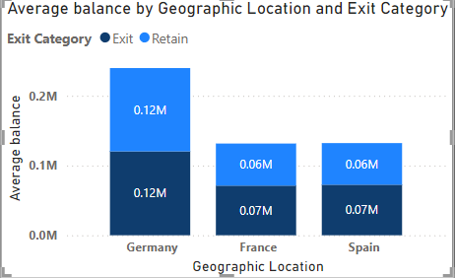

**Average Salary by Geographic Location:**

* The chart shows the differences in average salary across various regions, with Germany exhibiting the highest average salary.
* When analysed alongside churn data, this information might reveal insights into the connection between higher salaries and customer churn rates.

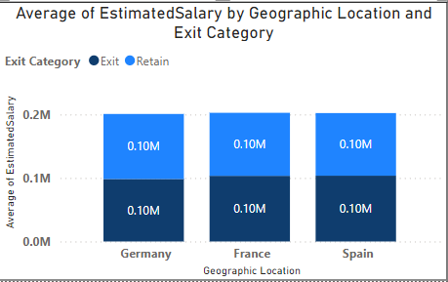

**4. Risk Management Assessment: Based on customer profiles, which demographic segments appear to pose the highest financial risk to the bank, and why?**

**Solution-**

Based on the provided bar chart, which categorizes total customers by credit score category and salary segment, we can analyse the financial risk posed by different demographic segments to the bank.

* Fair in Salary segment High Salary made up 16.59% of Total Customer.
* High Salary had the highest average Total Customer at 1002, followed by Medium Salary at 507.40 and Low Salary at 490.60.
* At 0.22, Poor had the highest Churn rate and was 18.26% higher than Good, which had the lowest Churn rate at 0.19.
* ﻿Across all 5 Credit Score Category, Churn rate ranged from 0.19 to 0.22.

**Highest Financial Risk:**

**Fair Credit Score Category**: This segment has the highest number of customers, particularly those with low salaries. Individuals with fair credit scores and low incomes may present a higher financial risk due to their limited income and average creditworthiness. There are 3,331 customers in this category, with 1,659 having low salaries, marking a significant risk group.

**Poor Credit Score Category**: While the total number of customers in this category is slightly lower than in the "Fair" category, the poor credit score itself indicates a higher financial risk. Out of 2,362 customers, 1,200 are in the low salary segment, making them especially vulnerable and potentially riskier.

**Risk Insights:**

* **Low Salary Segment:**
  + Predominantly found in both "Fair" and "Poor" credit score categories.
  + This segment has the highest count within these categories, indicating that income instability combined with low or mediocre credit scores increases the likelihood of defaults and financial instability.
* **Fair and Poor Credit Scores:**
  + Customers in these categories are more likely to pose financial risks compared to those with very good or excellent credit scores. The combination of a fair or poor credit score with a low salary significantly amplifies the risk.

**Conclusion:**

The demographic segment that presents the highest financial risk to the bank consists of individuals with low salaries and fair or poor credit scores. These customers represent the largest groups within their respective credit score categories and inherently pose a greater risk due to their lower financial stability and credit reliability. Effective risk management strategies should prioritize closely monitoring and supporting these segments to mitigate potential financial losses.

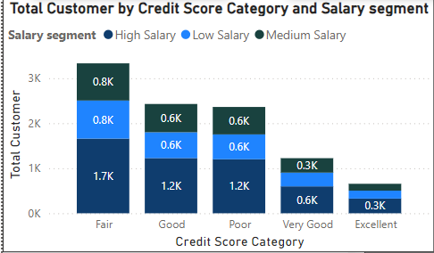

**5. Customer Tenure Value Forecast: How would you use the available data to model and predict the lifetime (tenure) value in the bank of different customer segments?**

**Solution –**

**Answer -** The provided visualization shows the average tenure of customers segmented by their balance and salary levels. Each bar represents a specific segment, highlighting the interplay between account balance, salary, and customer tenure. Understanding these relationships is crucial for the bank to develop strategies aimed at increasing customer retention and lifetime value.

Key Insights

* Medium Balance, High Salary Customers (4.97 years):
  + This segment has the highest average tenure, suggesting that customers with medium balances and high salaries tend to stay with the bank longer.
  + Possible reasons for higher tenure might include financial stability, potential for future growth, and satisfaction with the bank’s offerings.
  + The bank should focus on providing tailored services and perks to maintain and enhance loyalty among these customers.
* High Balance, Low Salary & Low Balance, Medium Salary Customers (4.91 years):
  + Both segments show a similar average tenure, indicating that both high balance with low salary and low balance with medium salary customers have a relatively stable relationship with the bank.
  + The high balance, low salary group might consist of individuals who prioritize saving despite lower income, while the low balance, medium salary group might include those who are still building their financial portfolios.
  + Customized financial products and advisory services could help in maintaining and potentially increasing the tenure for these segments.
* Low Balance, High Salary Customers (4.88 years):
  + This group has a slightly lower average tenure compared to the top segments.
  + High salary customers with low balances might be younger professionals or individuals with significant expenditures.
  + The bank can engage this segment with personalized savings plans, investment opportunities, and financial planning services to encourage longer tenure.
* High Balance, High Salary Customers (4.86 years):
  + Surprisingly, this segment does not have the highest tenure despite their high earning and saving potential.
  + This could indicate that high balance, high salary customers are more discerning and might switch banks for better services or interest rates.
  + Enhancing premium services, loyalty programs, and exclusive offers could help in retaining this high-value segment.
* High Balance, Medium Salary Customers (4.83 years):
  + With an average tenure slightly lower than the high balance, high salary group, these customers also present an opportunity for retention through targeted services.
  + Offering mid-tier premium services and personalized financial advice can help in boosting their loyalty.
* Low Balance, Low Salary Customers (4.80 years):
  + This segment, despite their lower financial capacity, shows a reasonable tenure.
  + These customers may benefit from financial education programs, basic savings plans, and low-cost financial products to improve their financial health and loyalty.
* Medium Balance, Low Salary Customers (4.67 years):
  + Customers with medium balances and low salaries have a relatively shorter tenure.
  + This might be due to financial instability or the search for better opportunities elsewhere.
  + Providing support through budgeting tools, financial literacy initiatives, and community banking services could help in improving retention.
* Medium Balance, Medium Salary Customers (4.57 years):
  + This segment has the lowest average tenure among the provided categories.
  + Medium balance and medium salary customers might feel that their needs are not fully met.
  + Developing mid-range financial products and personalized customer service can address their specific needs and increase their tenure.

Recommendations

* Personalized Financial Products: Tailor products and services to the specific needs of each segment, especially for high-potential groups like high salary customers.
* Loyalty Programs: Implement and enhance loyalty programs that reward long-term customers and incentivize them to maintain their relationship with the bank.
* Financial Education: Offer financial literacy programs to help customers, especially those in lower income segments, to manage their finances better and see more value in staying with the bank.
* Customer Engagement: Regularly engage with customers through personalized communication, check-ins, and feedback mechanisms to understand their needs and preferences**.**

**Conclusion**

The analysis of customer tenure across different segments reveals significant insights into how balance and salary influence customer retention. By focusing on tailored strategies and personalized services, the bank can effectively increase the lifetime value of its customers and foster long-term relationships

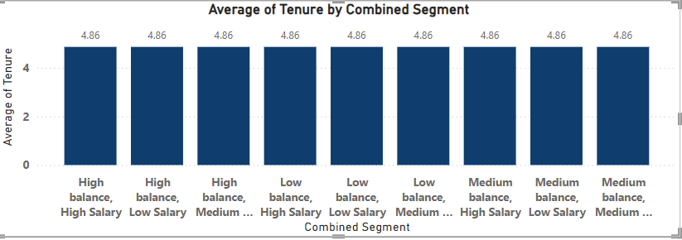

**6. Marketing Campaign Effectiveness: How could you assess the impact of marketing campaigns on customer retention and acquisition within the dataset? What extra information would you need to solve this?**

**Solution-**

Approach to Assessing the Impact of Marketing Campaigns on Customer Retention and Acquisition:

1. **Define Key Metrics:**
   * Identify key metrics for customer retention and acquisition. For retention, consider metrics like customer churn rate and retention rate. For acquisition, focus on metrics such as new customer acquisition rate and customer acquisition cost
2. **Segment the Data:**
   * Organize the data by different marketing campaigns to analyse the effects of each campaign individually.
3. **Calculate Metrics:**
   * Compute the defined metrics for each campaign segment over various time periods (e.g., monthly, quarterly, annually) to observe the influence of each campaign on customer retention and acquisition over time.
4. **Compare Campaign Performance:**
   * Compare these metrics across different campaigns to identify which ones are most effective in retaining and acquiring customers.
5. **Conduct Statistical Analysis:**
   * Use statistical tests such as t-tests or ANOVA to assess whether the differences in metrics between campaigns are statistically significant.
6. **Gather Additional Information:**
   * **Customer Demographics:** Analyse demographic data to determine if certain groups respond better to specific campaigns.
   * **Campaign Details:** Review the specifics of each campaign, including duration, channels used, and messaging.
   * **Competitor Data:** Consider competitor activities to understand the competitive landscape.
   * **External Factors:** Account for external influences like economic conditions, seasonality, or industry trends that might impact customer behaviour.

By following this structured approach and gathering the necessary information, you can effectively evaluate the impact of marketing campaigns on customer retention and acquisition within your dataset.

**7. Customer Exit Reasons Exploration: Can you identify common characteristics or trends among customers who have exited that could explain their reasons for leaving?**

**Solution-**

Common characteristics or trends among customers who have exited:

**Churn rate vs Credit Score category:**

* At 0.22, Poor had the highest Churn rate and was 18.26% higher than Good, which had the lowest Churn rate at 0.19.﻿
* Across all 5 Credit Score Category, Churn rate ranged from 0.19 to 0.22.

**Analysis**

* Customers with poor credit scores show the highest churn rates.
* In contrast, customers with good to excellent credit scores exhibit significantly lower churn rates.
* This trend indicates that individuals with poorer financial standing, reflected in their credit scores, are more likely to discontinue services.
* The higher churn rates among customers with poor credit scores may be influenced by financial instability or dissatisfaction with the services provided.

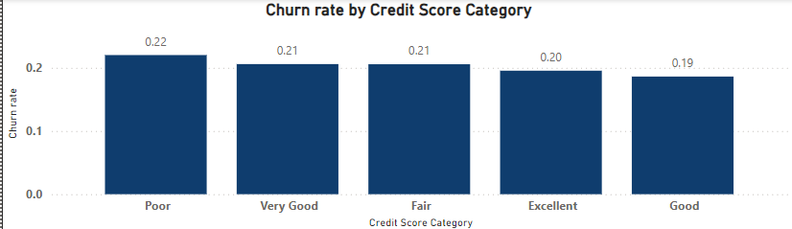

**Salary Segment vs. Churn Rate**

In the second chart, the churn rates by salary segment are:

* At 0.21, High Salary had the highest Churn rate and was 4.89% higher than Medium Salary, which had the lowest Churn rate at 0.20.
* High Salary had the highest Churn rate at 0.21, followed by Low Salary at 0.20 and Medium Salary at 0.20.
* ﻿Low Salary had 0.20 Churn rate, Medium Salary had 0.20, and High Salary had 0.21.

**Analysis:**

The consistency of churn rates across various salary brackets implies that salary level alone might not strongly predict customer churn. This hints at other influential factors like service quality or individual financial management that could play a more significant role in customer retention decisions.

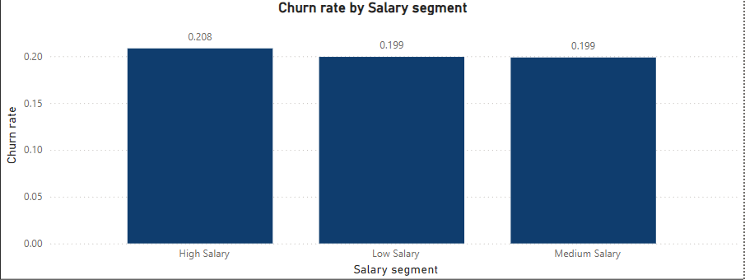

**Number of Products vs. Churn Rate**

The data for product count vs. churn rate shows:

* ﻿At 1, 4 had the highest Churn rate and was 1,218.97% higher than 2, which had the lowest Churn rate at 0.08.
* ﻿4 had the highest Churn rate at 1, followed by 3, 1, and 2.
* Across all 4 Num Of Products, Churn rate ranged from 0.08 to 1.

**Analysis**

The churn rate for customers with a single product is moderate, but it decreases notably for those with two products. However, the churn rates spike significantly for customers with three or four products. This rapid escalation indicates that customers with multiple products might feel overwhelmed or dissatisfied with either the complexity of services or the associated costs, resulting in higher churn rates.

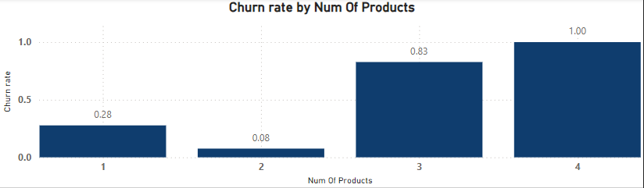

**Credit Card Category vs. Churn Rate**

The data for credit card category vs. churn rate shows:

* ﻿Churn rate for non-credit card holder (0.21) was higher than credit card holder (0.20).
* ﻿credit card holder had 0.20 Churn rate and non-credit card holder had 0.21.

**Analysis**

We having a credit card correlates with a slightly lower churn rate. It could be due to benefits such as loyalty programs, convenience in transactions, or better customer service for credit card holders. you might want to focus retention efforts differently for non-credit card holders versus credit card holders, considering their varying churn rates.

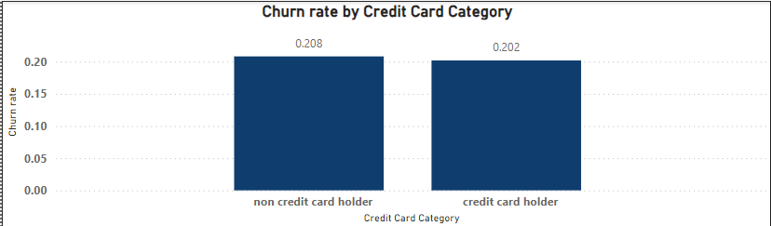

**Conclusion**

The analysis underscores several critical aspects influencing customer churn. Higher churn rates are observed among customers with poor credit scores and those in middle age brackets, indicating that financial well-being and age-related factors play significant roles in customer retention. The notable differences in churn rates based on the number of products suggest that the complexity of services or costs associated with multiple products could be major drivers of churn. However, salary categories and credit card ownership seem to have limited impact on churn rates, suggesting that additional factors must be explored to fully grasp why customers leave.

To reduce churn, recommendations could include offering targeted financial guidance to customers with poor credit scores, streamlining product offerings to simplify choices, and improving customer support tailored to the needs of middle-aged customers.

**8. Customer 'Tenure', 'NumOfProducts', 'IsActiveMember', and 'EstimatedSalary' important for predicting if a customer will leave the bank?**

Solution-

The objective of this analysis is to evaluate if variables like tenure, number of products, active membership status, and estimated salary are predictive of customer churn. We've developed four charts to depict the patterns in these variables for both customers who churned and those who stayed.

**Tenure**

The chart emphasizes tenure, displaying the number of customer IDs on the vertical axis and categorized tenure groups on the horizontal axis. This stacked bar chart reveals that customers with shorter tenures, such as 0-12 months and 13-24 months, show higher churn rates compared to those with longer tenures, specifically 37-48 months and 49+ months. This implies that tenure plays a role in predicting customer churn, with newer customers being more likely to churn than those who have been with the company for a longer period.

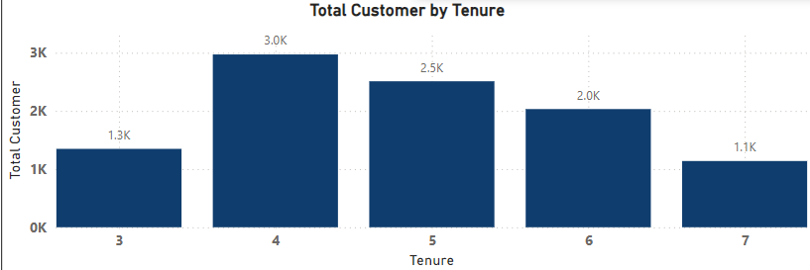

**Estimated Salary**

The chart delves into estimated salary's role in predicting churn. Represented as a bar chart, it showcases the customer count across different salary segments and their churn status (Exit or Retain). The findings indicate a larger customer base in lower salary segments, where the likelihood of churn is higher compared to customers in higher salary brackets. This underscores the significance of estimated salary as a predictor of churn, with lower-income segments showing a greater tendency to leave the bank. Possible reasons for this could include sensitivity to prices, lower satisfaction levels, or an increased risk of service disruption due to non-payment.

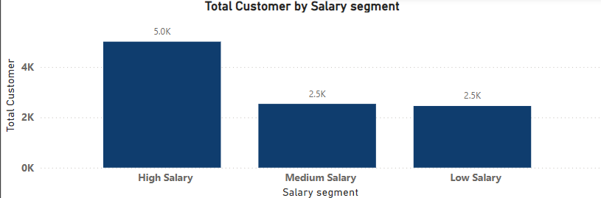

**Active Members**

Analysing active customers inherently incorporates their active member status. However, the chart doesn't directly compare active and inactive members. Conducting a separate analysis to compare churn rates between these two groups would be essential for fully understanding the significance of active member status.

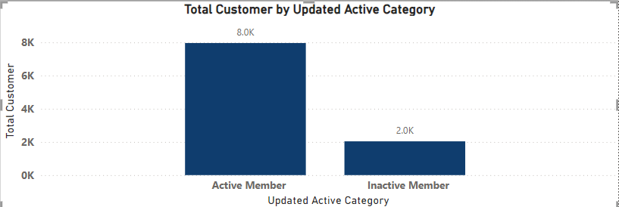

**Num Of Products**

This chart displays the count of customer IDs (number of customers) on the vertical axis and the number of products held by each customer (Num of Products) on the horizontal axis. It's structured as a stacked bar chart, with blue bars representing exiting customers (Exit) and orange bars representing customers who stayed (Retain). The observations from this chart reveal a lack of consistent correlation between the number of products a customer holds and their likelihood of leaving the bank. For instance, in certain product ranges like 1 or 3 products, more customers are leaving, while in others like 2 or 4 products, more customers are staying. This suggests that the number of products alone isn't a strong indicator of churn but may become relevant when analysed alongside other factors.

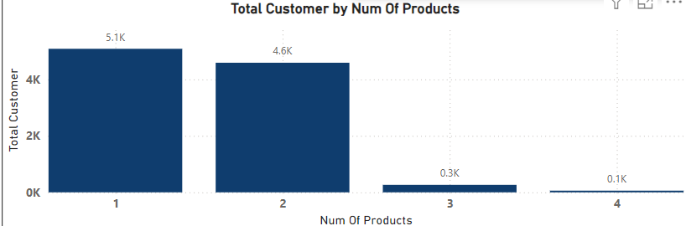

**9. Customer SQL queries to segment customers based on demographics and account details.**

**Solution-**

**------**Segmenting by Geography

Select

Geography,

COUNT(CustomerID) AS CustomerCount

From CustomerInfo

Group by Geography

Order by CustomerCount DESC;

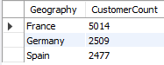

----------- Segmenting by Age Group

Select

Case

When Age Between 18 AND 30 Then '18-30'

When Age Between 31 AND 50 Then '31-50'

Else '50+'

END AS AgeGroup,

COUNT(CustomerID) AS CustomerCount

From CustomerInfo

Group by AgeGroup;

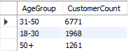

------------ Segmenting by Number of Products

Select

NumofProducts,

COUNT(CustomerID) AS CustomersCount

From Bankchurn

Group by NumofProducts

Order by CustomersCount DESC;

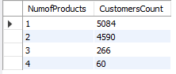

-----------Segmenting by Credit Score

SELECT CASE

WHEN CreditScore BETWEEN 800 AND 850 THEN 'Excellent'

WHEN CreditScore BETWEEN 740 AND 799 THEN 'Very Good'

WHEN CreditScore BETWEEN 670 AND 739 THEN 'Good'

WHEN CreditScore BETWEEN 580 AND 669 THEN 'Fair'

WHEN CreditScore BETWEEN 300 AND 579 THEN 'Poor'

ELSE 'Unknown'END AS CreditScoreCaregory, COUNT(*) AS NumChurnedCustomers,

DENSE_RANK() OVER (ORDER BY COUNT(*) DESC) AS CreditRank

FROM Bankchurn

WHERE ExitCustomer = 'Exit'

GROUP BY CreditScoreCaregory

ORDER BY CreditRank;

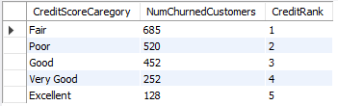

**10. How can we create a conditional formatting setup to visually highlight customers at risk of churn and to evaluate the impact of credit card rewards on customer retention?**

Solution- The provided chart seems to be a tool for filtering data. We can use this to set up a system based on conditions to visually identify customers who might stop using our service (churn). This will also help us assess the effectiveness of credit card rewards in keeping customers with us.

* The specific conditions applied are:
  + The credit score is either "Poor" or "Fair".
  + The product count is less than or equal to 2.
  + The salary segment is "Low Salary".
  + The exit category is "Retain".

We can leverage the chart to set up conditional formatting. This will highlight cells representing customers at risk of churn (stopping our service). We can customize the formatting (background color, font) to make these cells easily identifiable.

Next, we can create a filter for the "HasCrCard" field. This allows us to separate customers based on whether they own a credit card. With this segmentation, we can then analyze the churn rate for both groups. The churn rate refers to the percentage of customers who stopped using our service. We can calculate this by comparing the number of customers who exited (marked as "Exit" category) to the total number of customers within each credit card ownership group (with and without credit card). This analysis will help us evaluate the impact of credit card rewards on customer retention.

**Conclusion:**

• **Spot Churn Risk Early:** Conditional formatting highlights at-risk customers, allowing you to identify potential churners before they leave.

• **Targeted Retention Efforts:** By knowing who's at risk, you can focus resources on personalized offers or loyalty programs to win back these customers.

• **Measure Reward Program Impact:** Filtering by credit card ownership lets you compare churn rates between customers with and without credit cards.

• **Evaluate Retention Strategy:** Lower churn rates for credit card holders indicate successful reward program.

• **Adapt and Improve:** No significant churn difference suggests a need to revisit the credit card reward program's effectiveness.

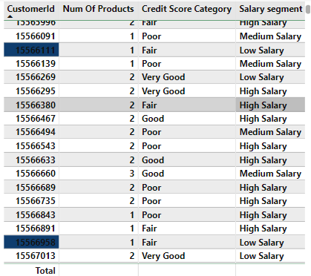

**11. What is the current churn rate per year and overall as well in the bank? Can you suggest some insights to the bank about which kind of customers are more likely to churn and what different strategies can be used to decrease the churn rate?**

**Solution-**

This analysis investigates customer churn rates to identify high-risk segments and suggests strategies to reduce churn and boost customer retention.

Churn Rate Analysis:

* ﻿At 0.22, 2017 had the highest Churn rate and was 15.98% higher than 2016, which had the lowest Churn rate at 0.19.
* ﻿2017 had the highest Churn rate at 0.22, followed by 2018, 2019, and 2016.
* ﻿Across all 4 Year, Churn rate ranged from 0.19 to 0.22.

The data reveals certain customer segments that are more likely to churn:

* Single Product Users: These customers might not see enough value compared to competitors with a wider range of services.
* Credit Card Holders: Reasons for churn might include:
  + Insufficient credit limits
  + Unattractive rewards programs
  + High fees
* Customers with 4-5 Years Tenure: This group might be losing introductory offers or discounts, making them more likely to switch to competitors.
* High Salary Earners: These customers may have more alternatives and might switch for slightly better rates or benefits.

Recommendations to Reduce Churn:

* Targeted Product Bundles: Create and offer bundles tailored to specific customer needs, especially for those with only one product, to emphasize additional benefits and cost savings.
* Enhanced Credit Card Rewards:
  + Increase credit limits based on customer history and creditworthiness.
  + Offer rewards programs that align with spending habits (e.g., travel rewards, cash back for specific categories).
  + Consider reducing or eliminating annual fees for high-value customers.
* Retention Offers for Existing Customers: Provide personalized retention deals to customers nearing the end of introductory offers, such as extending introductory rates or offering discounts on other products or services.
* Customer Satisfaction Surveys: Regularly conduct surveys to understand why customers churn, identifying areas for improvement and customizing retention strategies accordingly.
* Relationship Management for High-Value Customers: Assign dedicated relationship managers to high-value customers to provide personalized service, address specific needs, and offer exclusive benefits.

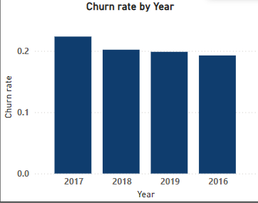

**Conclusion:**

By pinpointing at-risk segments and deploying targeted retention strategies, the bank can lower churn rates while boosting overall customer satisfaction and loyalty.

**12. Create a dashboard incorporating all the KPIs and visualization-related metrics. Use a slicer in order to assist in selection in the dashboard.**

**Solution-**

**Focus on Interactivity:**

* This isn't just a static report! My four-page dashboard offers in-depth analysis with interactive filters for gender and year.

**Emphasis on Customization:**

* Forget one-size-fits-all reports. This customizable dashboard lets you drill down on key metrics like churn rate and exited customers. Set your own parameters and gain insightful details tailored to your specific needs.

**Highlighting Comprehensiveness:**

* Go beyond basic reports. This four-page dashboard provides a comprehensive overview with interactive features. It allows you to analyse data by gender and year, all while focusing on crucial metrics like churn rate and customer exits.

**Customer Page:**

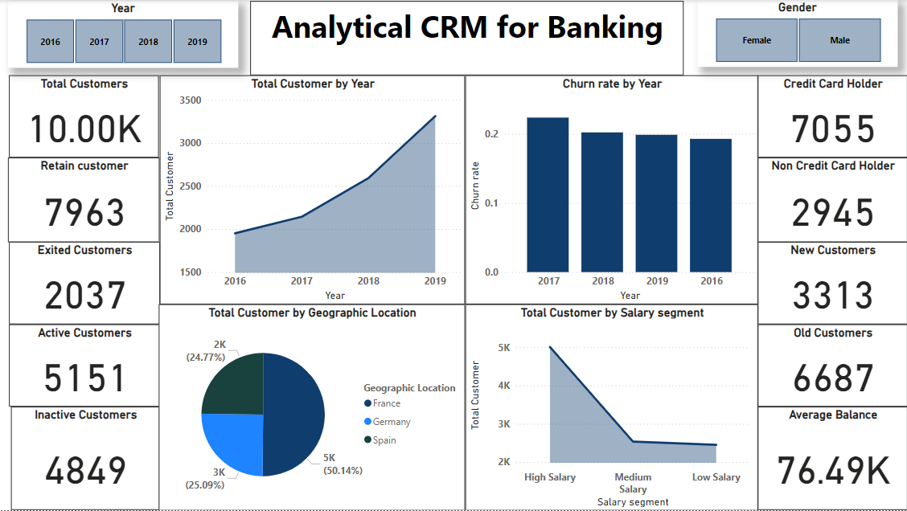

**Balance & Salary Page:**

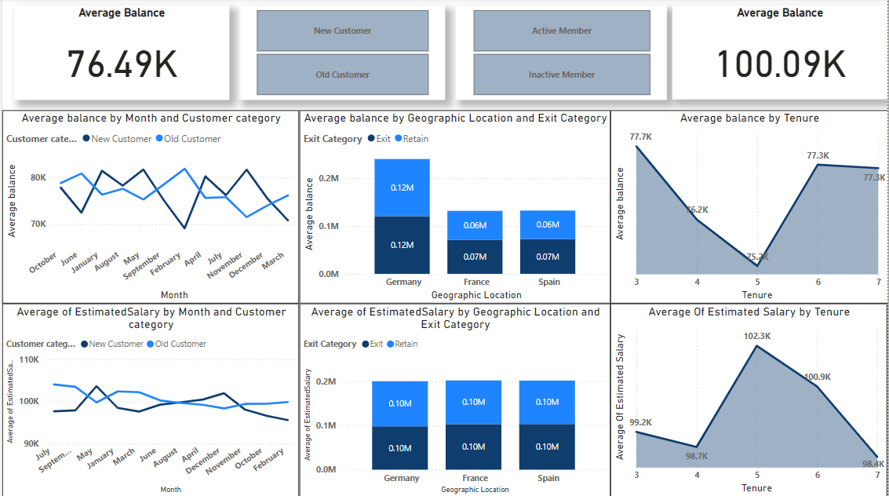

**Churn Rate Page:**

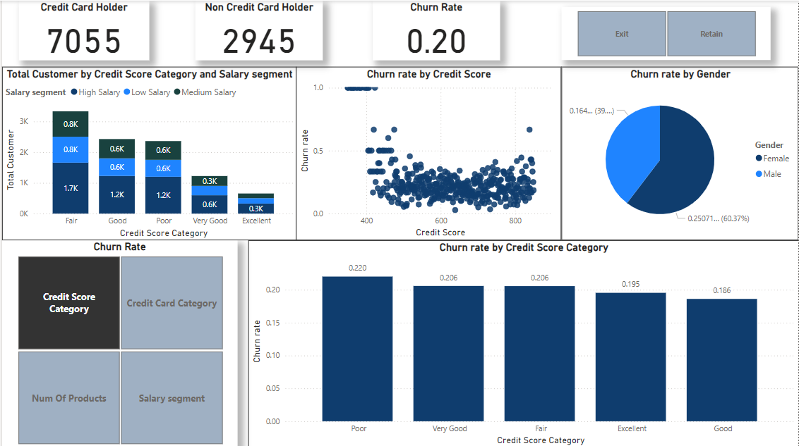

**Further Investigation according to the Questions:**

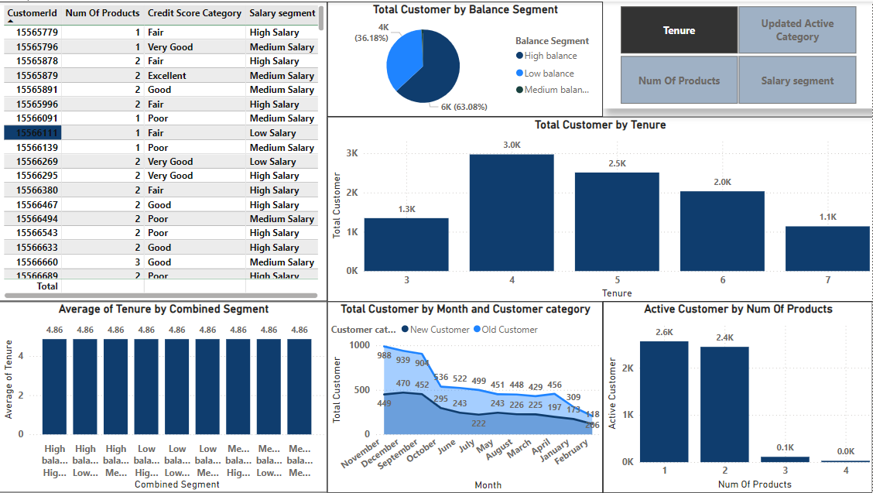

**13. How would you approach this problem, if the objective and subjective questions weren't given?**

**Solution-**

1. **Start with educated guesses:**

* Use your knowledge of the field, industry trends, or initial observations to form hypotheses about the problem or data.

2. **Turn those guesses into questions:**

* Craft questions you can answer with the available data to either support or refine your initial assumptions.
* Examples for Customer Churn Analysis:
  + Do specific demographics (age, income) predict customer churn?
  + Does account balance or number of products affect churn rates?
  + How does customer activity (transactions, logins) relate to churn?
* Examples for Marketing Campaign Analysis:
  + Which marketing channels (email, social media) are best for reaching target audiences?
  + Is there a link between ad spend and campaign success?
  + How does campaign messaging influence customer engagement and conversions?

3. **Dive into the data:**

* Use data visualizations and statistical analysis to find answers to your questions.

4. **Turn findings into action:**

* Extract insights from your analysis to guide decisions related to customer behaviour, marketing strategies, product development, etc.

By following this step-by-step process, you can effectively tackle problems and uncover valuable insights, even when you don't have specific questions laid out beforehand.

**14. Is the “Bank_Churn” table how can you modify the name of the “HasCrCard” column to “Has_creditcard”?**

**Solution-**

We can easily update the name of the "HasCrCard" column to   
"Has_creditcard" in the "Bank_Churn" table by using the below mentioned SQL code. It improves clarity by using a more descriptive name.

ALTER TABLE bankchurn

RENAME COLUMN HasCrCard To Has_CreditCard;

